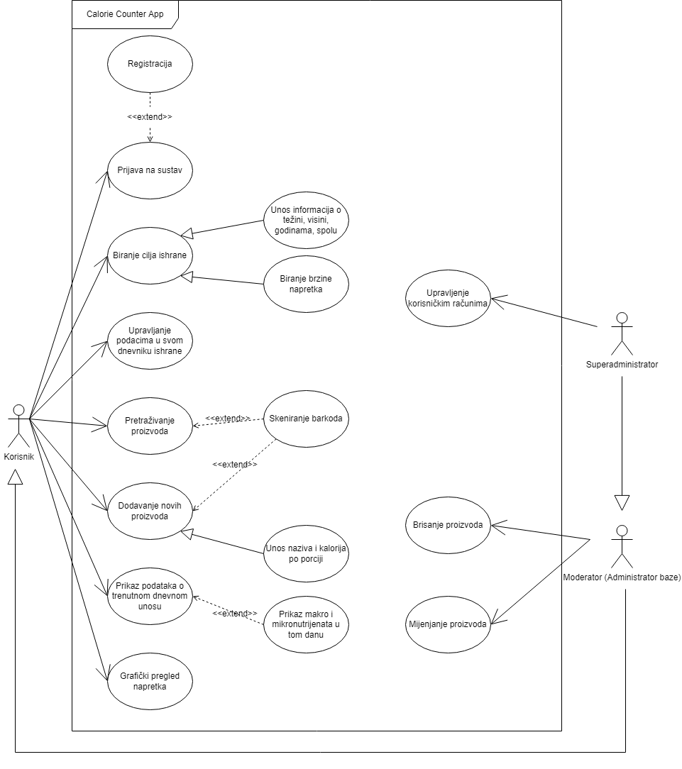

|  |  |
| --- | --- |
| **ID:** | **1** |
| **Title:** | Prijava na sustav |
| **Description:** | Korisnik se prijavljuje u sustav |
| **Primary Actor:** | Korisnik, moderator, superadministrator |
| **Preconditions:** | Korisnik se nije prijavio u sustav |
| **Postconditions:** | Korisnik je prijavljen u sustav i može nastaviti dalje |
| **Main  Success Scenario:** | Korisnik unosi svoje korisničko ime i lozinku, sustav provjerava unesene podatke i ako su ispravni korisniku se daje pristup sustavu. |
| **Extensions:** | Ako uneseni podaci nisu ispravni, korisniku se daje do znanja kako je pogriješio i da unese ispravne podatke |
| **Frequency of Use:** | Svaki put kada korisnik prvi put pristupa sustavu, ulazna točka sustava |
| **Status:** | - |
| **Owner:** | - |
| **Priority:** | Visok |

|  |  |
| --- | --- |
| **ID:** | **2** |
| **Title:** | Registracija |
| **Description:** |  |
| **Primary Actor:** |  |
| **Preconditions:** |  |
| **Postconditions:** |  |
| **Main  Success Scenario:** |  |
| **Extensions:** |  |
| **Frequency of Use:** |  |
| **Status:** |  |
| **Owner:** |  |
| **Priority:** |  |

|  |  |
| --- | --- |
| **ID:** | **3** |
| **Title:** | Upravljanje korisničkim računima |
| **Description:** |  |
| **Primary Actor:** |  |
| **Preconditions:** |  |
| **Postconditions:** |  |
| **Main  Success Scenario:** |  |
| **Extensions:** |  |
| **Frequency of Use:** |  |
| **Status:** |  |
| **Owner:** |  |
| **Priority:** |  |

|  |  |
| --- | --- |
| **ID:** | **4** |
| **Title:** | Brisanje proizvoda |
| **Description:** |  |
| **Primary Actor:** |  |
| **Preconditions:** |  |
| **Postconditions:** |  |
| **Main  Success Scenario:** |  |
| **Extensions:** |  |
| **Frequency of Use:** |  |
| **Status:** |  |
| **Owner:** |  |
| **Priority:** |  |

|  |  |
| --- | --- |
| **ID:** | **5** |
| **Title:** | Mijenjanje proizvoda |
| **Description:** |  |
| **Primary Actor:** |  |
| **Preconditions:** |  |
| **Postconditions:** |  |
| **Main  Success Scenario:** |  |
| **Extensions:** |  |
| **Frequency of Use:** |  |
| **Status:** |  |
| **Owner:** |  |
| **Priority:** |  |

|  |  |
| --- | --- |
| **ID:** | **6** |
| **Title:** | Biranje cilja ishrane |
| **Description:** |  |
| **Primary Actor:** |  |
| **Preconditions:** |  |
| **Postconditions:** |  |
| **Main  Success Scenario:** |  |
| **Extensions:** |  |
| **Frequency of Use:** |  |
| **Status:** |  |
| **Owner:** |  |
| **Priority:** |  |

|  |  |
| --- | --- |
| **ID:** | **7** |
| **Title:** | Upravljanje podacima u svom dnevniku ishrane |
| **Description:** |  |
| **Primary Actor:** |  |
| **Preconditions:** |  |
| **Postconditions:** |  |
| **Main  Success Scenario:** |  |
| **Extensions:** |  |
| **Frequency of Use:** |  |
| **Status:** |  |
| **Owner:** |  |
| **Priority:** |  |

|  |  |
| --- | --- |
| **ID:** | **8** |
| **Title:** | Pretraživanje proizvoda |
| **Description:** |  |
| **Primary Actor:** |  |
| **Preconditions:** |  |
| **Postconditions:** |  |
| **Main  Success Scenario:** |  |
| **Extensions:** |  |
| **Frequency of Use:** |  |
| **Status:** |  |
| **Owner:** |  |
| **Priority:** |  |

|  |  |
| --- | --- |
| **ID:** | **9** |
| **Title:** | Dodavanje novih proizvoda |
| **Description:** |  |
| **Primary Actor:** |  |
| **Preconditions:** |  |
| **Postconditions:** |  |
| **Main  Success Scenario:** |  |
| **Extensions:** |  |
| **Frequency of Use:** |  |
| **Status:** |  |
| **Owner:** |  |
| **Priority:** |  |

|  |  |
| --- | --- |
| **ID:** | **10** |
| **Title:** | Skeniranje barkoda |
| **Description:** |  |
| **Primary Actor:** |  |
| **Preconditions:** |  |
| **Postconditions:** |  |
| **Main  Success Scenario:** |  |
| **Extensions:** |  |
| **Frequency of Use:** |  |
| **Status:** |  |
| **Owner:** |  |
| **Priority:** |  |

|  |  |
| --- | --- |
| **ID:** | **11** |
| **Title:** | Prikaz podataka o trenutnom dnevnom unosu |
| **Description:** |  |
| **Primary Actor:** |  |
| **Preconditions:** |  |
| **Postconditions:** |  |
| **Main  Success Scenario:** |  |
| **Extensions:** |  |
| **Frequency of Use:** |  |
| **Status:** |  |
| **Owner:** |  |
| **Priority:** |  |

|  |  |
| --- | --- |
| **ID:** | **12** |
| **Title:** | Prikaz makro i mikronutrijenata u tom danu |
| **Description:** |  |
| **Primary Actor:** |  |
| **Preconditions:** |  |
| **Postconditions:** |  |
| **Main  Success Scenario:** |  |
| **Extensions:** |  |
| **Frequency of Use:** |  |
| **Status:** |  |
| **Owner:** |  |
| **Priority:** |  |

|  |  |
| --- | --- |
| **ID:** | **13** |
| **Title:** | Grafički pregled napretka |
| **Description:** |  |
| **Primary Actor:** |  |
| **Preconditions:** |  |
| **Postconditions:** |  |
| **Main  Success Scenario:** |  |
| **Extensions:** |  |
| **Frequency of Use:** |  |
| **Status:** |  |
| **Owner:** |  |
| **Priority:** |  |